PSSI Science Project Reporting Template

️ | The PSSI Implementation Team is compiling a technical report to demonstrate the important research and advancements made by the Science Branch through the PSSI funding. The technical report will include a 3-4 page summary (including graphics and figures) for each project to show their key results and findings. Please fill in the following fields and sections for your project to be included in the report. Feel free to include and draw from any reports or presentations previously created through your research.  A plain language science bulletin will also be created to follow up on last year’s “DFO Pacific Region Science Bulletin, 2024. New research and monitoring for Pacific salmon and their ecosystems.” While the first bulletin introduced project backgrounds, methods, and timelines, this new bulletin will highlight the projects’ results, key findings, and conclusions with links to reports and data available. The bulletin will include a 1-2 page summary for each project gleaned from the content entered below.  ️ Completed forms are due January 7, 2026.  *Please include or send separately any graphics or pictures (with photo credits) that will help promote the projects.

PART 1: PROJECT METADATA

General Project Information
Project ID (number) | Project Title
2436 | Chum whole genome sequencing for improved stock delineation
Project Leads | Collaborations and External Partners
Tigano, Anna; Rondeau, Eric; Healy, Timothy; Wellband, Kyle. | N/A
Location (if applicable) | N/A
PBS, Nanaimo, BC | N/A

Geographic and Stock Information
Salmon species (if applicable) | Waterbodies (if applicable)
Chum | Fraser, Strait of Georgia, Puget Sound
Life history phases (if applicable) | Region
Spawning adults | Southern BC and Puget Sound/Hood Canal
Stock (if applicable) | Population (if applicable)
Click or tap here to enter text. | Click or tap here to enter text.
Conservation Unit (if applicable)
Fraser, Howe and Georgia Strait – Southern Fjords

🧰 PART 2: PROJECT METRICS

Project Outputs
Include any anticipated outputs denoted as (in progress). Please include links to any outputs available online so they can be referenced in the report.
List scientific publications and technical reports (with links)
Tigano A, Long K, Healy T, Wellband K, Rondeau E. Increased genetic resolution in southern BC chum enabled by whole genome data. In preparation.
List datasets generated (with links)
Whole genome data for 1441 individuals will be uploaded to NCBI/ENA
Describe dataset locations and data management systems
The raw genomic data are stored in multiple locations and will be soon uploaded onto a public database (NCBI/ENA).
List code, programs, or other software created (with links)
Code will be published on GitHub/Zenodo along with the peer-reviewed publications.
List communication or social media products
Coastwide Salmon Genetics, Fairbanks, Alaska, May 2025
Pacific Salmon Initiative Symposium, Nanaimo, December 2025
List and describe field work completed
The tissue samples used in this work were stored in the GSI lab archive.
List and describe samples collected/analyzed (number of samples)
We sequenced the genomes of 1441 individuals overall.
List and describe large capital assets or equipment acquired
N/A?

PART 3: WRITTEN CONTENT

Highlights
Please summarize in 2-3 bullets:
- The main idea of the project
- Key findings
- Implications of these findings for salmon and decision-makers
- For a more technical audience, but still as plain language as possible
- The Genetic Stock Identification (GSI) of chum in southern BC, especially in the Fraser River and the Strait of Georgia (“SOG” hereafter), has poor resolution.
- We identified informative genetic markers (single nucleotide polymorphisms, SNPs) to improve the current SNP panel for GSI (“GSI panel” hereafter) and increase genetic resolution in the Fraser and SOG. In particular, we were able to differentiate 1) chum returning to the Chilliwack River versus the rest of the Fraser and 2) chum from spawning location in the SOG west versus SOG east.
- These improvements will improve stock assessment in those two areas.

Background
Please provide 1-2 paragraphs to summarize
- The relevant biological, environmental, and/or management context
- What knowledge gap or demand were you trying to fill?
- Collaboration and partner relationships
GSI is routinely used in the Northeast Pacific to inform the management of Pacific salmon species, especially chinook (Oncorhynchus tshawytscha), sockeye (Oncorhynchus nerka), coho (Oncorhynchus kisutch), and chum (Oncorhynchus keta). Of these four species, chum is the most widely distributed in the Pacific Ocean, and displays the weakest population structure across its range. Chum is managed jointly by Canada and the United States under the Pacific Salmon Treaty to ensure that the fishery is sustainable on the long term, and GSI has become a pillar of effective stock assessment and management. Bilateral efforts between Canada and the USA have led to the development of GSI panels in each of the two countries, with bilateral collaboration ensuring a large overlap of SNPs between the panels developed in the two countries to foster exchange of data and results. The Canada chum GSI panel consists of 535 SNPs originally sourced from a series of RAD-seq (a genomic method to genotype thousands of genome-wide SNPs) studies targeting different parts of the range, but limited to Washington and Alaska (to be refined Small et al PSC report, Mckinney et al. 2020; Mckinney et al. 2022), and subsequently optimized independently from the USA counterpart. The Canadian baseline, the genetic database used as reference to assign samples of unknown origin to their stock of provenance, includes genotypic data for over 32,000 individuals from 384 collections across the species range (October 2025).
Despite the genotyping efforts, some areas in southern BC remain poorly resolved, with two areas being of particular interest: the lower Fraser and SOG. In the Fraser, the Albion test fishery, which provides crucial information on chum returns for stock assessment, relies on accurate separation of Chilliwack River returns from the rest of the Fraser, but it is currently challenging. To avoid misassignment and increase accuracy, albeit at the cost of resolution, all collections from the Fraser are lumped into a single reporting unit. In the Strait of Georgia, two main reporting units are currently recognized: Howe-Burrard, including collections from Howe Sound and Burrard Inlet; and Strait of Georgia, including collections from the west and east side of the strait that are not included in the Howe-Burrard reporting unit. Even though assignment accuracy between these two reporting units is low with the current SNP panel, the analysis of the baseline samples suggest that additional efforts may help discriminate collections from the east and the west side of the Strait, thus increasing overall resolution in the SOG.

️ Methods and Findings
Please insert a few paragraphs to summarize:
- Main methods used
- Products and tools produced
- Advancements in methodology, technology, and application
- Advancements in communication and knowledge transfer
- Key results and information generated
We used whole genome sequencing to fully characterize genome-wide sequence variation within the Fraser, SOG and adjacent areas, including Puget Sound, Johnstone Strait, and West Coast Vancouver Island. We sequenced 15 individuals from each of 45 collections in these areas (Fig.1), and called variants using stringent quality filters. We identified more than 11 million SNPs (excluding rare variants) across 594 individuals, which is 21,000X the number of SNPs included in the current GSI panel (535 SNPs). We performed Principal Component Analyses (PCAs) to investigate population structure. Analyses based on 100,000 randomly selected SNPs, a subsample of the full catalogue of genomic variation, showed great resolution improvement compared to the reference baseline including data from the 535 SNPs of the GSI panel (Fig.2): the Fraser, SOG and Puget Sound were markedly differentiated from each other, the North Puget collections were clearly separated from the rest of the individuals, and we started to observe differentiation between Chilliwack and Fraser, and SOG east and west. More focused analyses including only Fraser-Chilliwack or SOG samples revealed significant differentiation within those two areas. To identify a set of highly informative SNPs to add to the GSI panel, we calculated F_{ST}, a measure of genetic differentiation, across all SNPs within each of the two areas and selected the 100 SNPs showing the highest differentiation in each area (Fraser and SOG).
We extracted the genotype data from the whole genome sequencing dataset for the SNPs in the GSI panel and the 200 highly differentiated SNPs in the Fraser and the SOG. 121 of the 535 SNPs in the GSI panel were not present in the whole genome dataset because they were either excluded due to quality and/or low minor allele frequency filters, or because they were not variable in the target geographic area. Using Leave-One-Out (LOO) analyses we tested for changes in GSI accuracy between the current GSI panel (414 SNPs) and the improved panel that includes the GSI panel and the 200 differentiated SNPs (614 SNPs). The addition of the 200 SNPs resulted in much improved assignments (Fig.3 and 4). When we tested the current GSI panel, assignments to the SOG had low true positive rates, indicating low assignment probabilities or misassignments, and individuals from each side of the strait showed similar probabilities to be assigned to SOG east or west (Fig.3). In the Fraser, Chilliwack individuals tended to be assigned to the rest of the Fraser, resulting in high false positive rate when the Fraser was the target reporting unit, and low true positive rates when the Chilliwack was the target reporting unit (Fig.3). In contrast, when we used the improved panel, all analyses showed low false discovery rate (FDR < 0.05) and high true discovery rate, hitting the target accuracy threshold of 80% of individuals assigned with 80% probability assignment, except for Chilliwack, which showed great improvement but fell slightly short on the true positive rate (70-75% instead of > 80%, Fig.4) . True positive rate of assignment to Chilliwack is likely to increase with greater sample sizes, which are generally targeted for the construction of the reference baseline. Overall, by adding 200 highly differentiated SNPs, true positive rate increased by 48% on average at a 80% of assignment probability threshold in the four target areas, with the greatest increases in Chilliwack (66%) and SOG west (63%), followed by SOG east (49%; Figs.3 and 4). The Fraser had the lowest increase in true positive rate as it was already high in the original GSI panel, even though its false discovery rate was the highest (10%) due to Chilliwack individuals tending to assign to the Fraser (Figs.3 and 4). Similarly, false discovery rate decreased by 5% and accuracy increased by 10% on average.
Finally, with funding from PSSI we expanded our whole genome dataset to include one collection from each designated Conservation Unit (CU) in BC and additional collections from Alaska, for a total of 512 individuals from 44 collections/CUs from Washington to Alaska. This dataset will be used to further characterize population structure across the BC range and beyond, investigate signatures of local adaptation and the environmental factors driving it, assess variation in genomic vulnerability to climate change across the NE Pacific range, estimate genetic diversity, reconstruct past changes in effective population size, and potentially further improve the GSI panel to increase geographic resolution of GSI.

Insights
Please insert a few paragraphs to summarize:
- What this project has added to knowledge about salmon populations, health, or ecosystems.
- How this project informs salmon management:
  - decisions
  - policy guidance
  - trade-offs
  - planning
- Addition of knowledge to understanding:
  - limiting factors/stressors/threats/ pathways of effects/risks
  - biologically significant thresholds
  - cumulative impacts
- Sources of uncertainty
A good understanding of population structure is crucial for the effective management of Pacific salmon, including chum. The latest study investigating population structure in BC and Washington is almost 20 years old, and was based on only 89 SNPs, granting rather limited resolution, especially in the Fraser and SOG (Small et al. . Additionally, the genomic data used to develop the current GSI panel were collected from American spawning locations only, and the genomic variation that is unique to Canadian stocks was not captured. With our work on chum funded by PSSI we have characterized population structure in southern BC and Puget Sound and identified SNPs that are highly differentiated and informative of population differentiation in the areas of interest. An improved GSI panel based on our results will greatly improve GSI resolution and accuracy in the Fraser and SOG, and beyond.
We have been contacted multiple times in recent times for information on population structure in chum, both internally within DFO and by American agencies, to better inform stock assessment and management and hatchery practice. For example, apparent lack of population structure in the Fraser has led to the movement of chum of different origins among hatcheries. Our results provide evidence of population differentiation within the Fraser, which should be kept into account in hatchery practice to ensure the preservation of unique genetic diversity and potentially local adaptations to different parts of the Fraser watershed.
Our NE Pacific range whole genome sequencing dataset will provide additional information on population structure across the chum North American range and a suite of ad hoc genomic analyses, including assessment of genetic diversity, demographic reconstructions, measures of genomic vulnerability to climate change, will provide information to prioritize conservation efforts and ensure long-term sustainability of fisheries.

⏩ Next Steps
Please insert 1-2 paragraphs to summarize:
- Remaining knowledge gaps and recommendations for future studies
- How can/should the project findings be operationalized for salmon conservation and management?
- In the coming months, we will perform additional assignment tests using individuals that were not originally included in the SNP discovery and GSI panel improvement analyses, and eventually add the informative SNPs identified to the current chum GSI panel.
- Dissemination of results at the Pacific Salmon Initiative Symposium has spurred interest into further characterizing fine population structure of chum in the Fraser and preliminary results are encouraging in this regard. We are also working on characterizing genomic areas of differentiation that could be associated with traits of interest, such as timing of migration. Finally, we’ll expand our investigations to the rest of the BC range and beyond as described above.
- The results of our study will result in an improved GSI panel that will help differentiate chum from different areas in southern BC at an unprecedented resolution, thus informing and improving hatchery practices and stock assessment.

📈 Tables and Figures
Please provide captions and numbering for any tables and figures. Graphics can be copied below or e-mailed separately.
- Include a brief caption with each figure and table in the box below
- Number each table and figure, and include references in the above sections where appropriate.
- 1-3 figures are recommended per project
Figure 1. Map showing the spawning location of the collections used to increase GSI resolution in the Fraser River and in the Strait of Georgia.
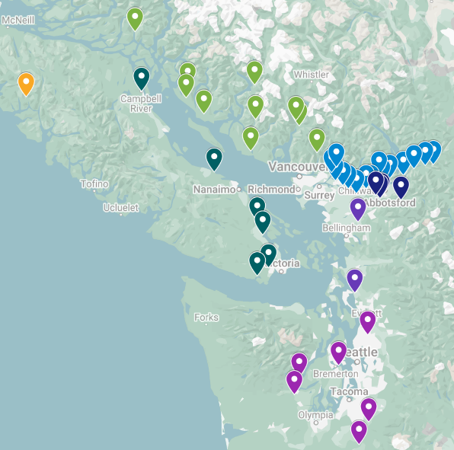

Figure 2. PCA plots showing population differentiation based on either the 535 SNPs included in the GSI panel (on the left) or 100,000 SNPs sampled randomly from a catalogue of 11 million SNPs from across the genome (on the right). The comparison shows higher genetic resolution when using more SNPs identified from the collections on interest.
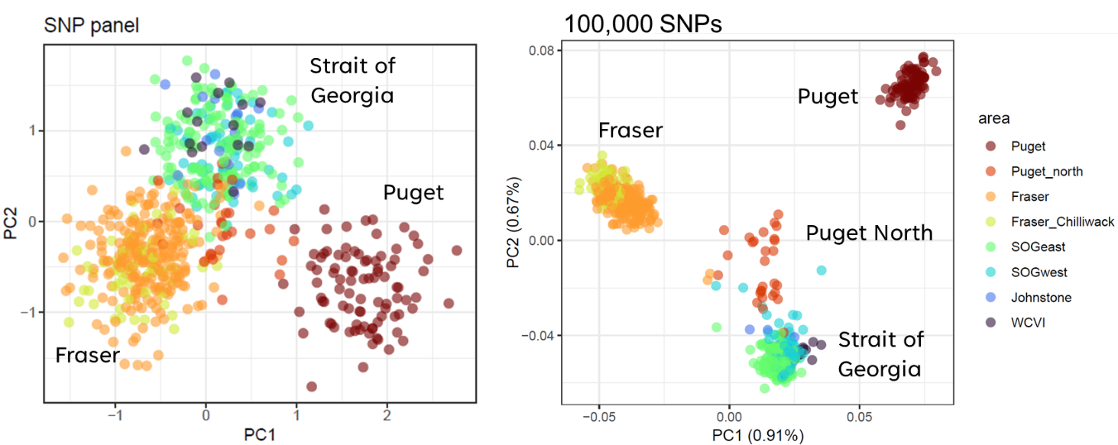

Figure 3. Plots summarizing LOO analyses results for the current GSI panel for each of the four target geographic areas: Strait of Georgia on the left (West and East) and Fraser on the right (Fraser-excluding Chilliwack and Chilliwack).
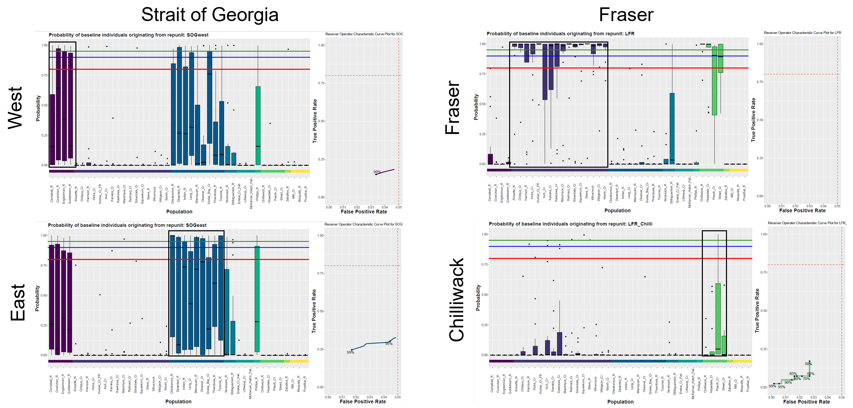

Figure 3. Plots summarizing LOO analyses results for the improved GSI panel (current + 200 highly differentiated SNPs) for each of the four target geographic areas: Strait of Georgia on the left (West and East) and Fraser on the right (Fraser-excluding Chilliwack and Chilliwack).

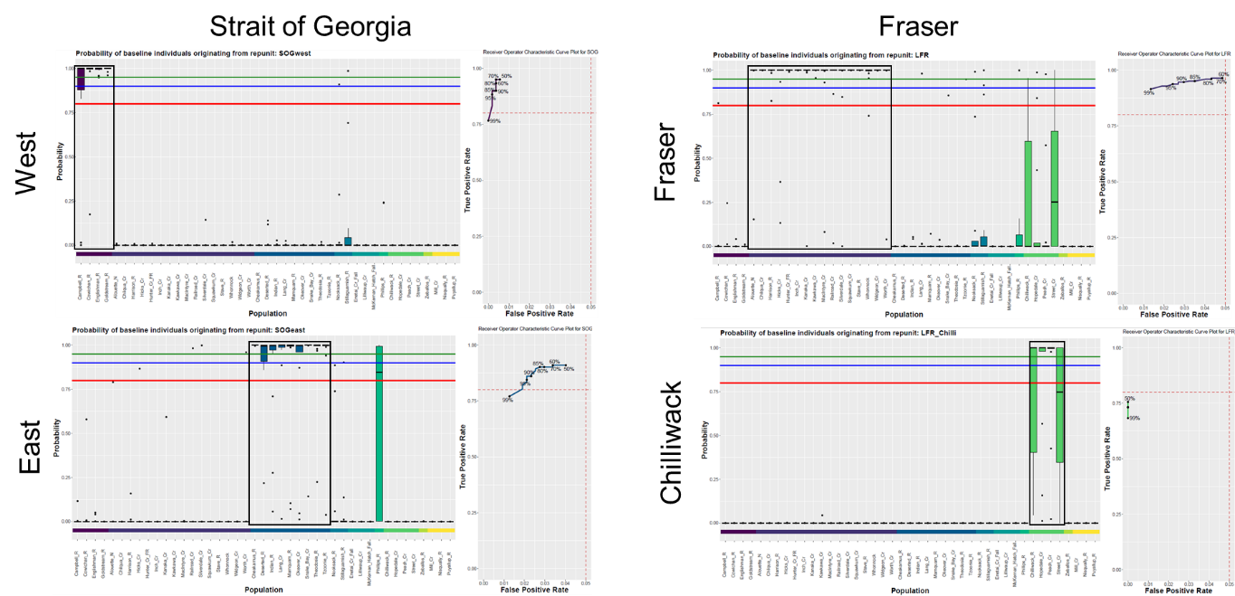

📈 References
Include full references for any publications referenced in other sections. Please format references in Harvard style according to Instructions to Authors for the Canadian Journal of Fisheries and Aquatic Sciences, at Canadian Science Publishing.
McKinney, G., McPhee, M.V., Pascal, C., Seeb, J.E. and Seeb, L.W., 2020. Network analysis of linkage disequilibrium reveals genome architecture in chum salmon. G3: Genes, Genomes, Genetics, 10(5), pp.1553-1561.

McKinney, G.J., Barry, P.D., Pascal, C., Seeb, J.E., Seeb, L.W. and McPhee, M.V., 2022. A new genotyping‐in‐thousands‐by‐sequencing single nucleotide polymorphism panel for mixed‐stock analysis of chum salmon from coastal Western Alaska. North American Journal of Fisheries Management, 42(5), pp.1134-1143.

Small, M., Warheit K., Pascal C., Seeb L., Ruff C., Zischke J., et al., Chum Salmon Southern Area Genetic Baseline Enhancement Part 1 and Part 2: Amplicon Development, Expanded Baseline Collections, and Genotyping. PSC report S14-I17 & S15-I09

Small, M.P., Rogers Olive, S.D., Seeb, L.W., Seeb, J.E., Pascal, C.E., Warheit, K.I. and Templin, W., 2015. Chum salmon genetic diversity in the northeastern Pacific Ocean assessed with single nucleotide polymorphisms (SNPs): Applications to fishery management. North American Journal of Fisheries Management, 35(5), pp.974-987.

